How to mount a image using Poweriso.
File Types
.ISO, .NRG, .DAA, .CUE, etc
Steps
- First install the poweriso software present in software folder.
- While installing poweriso, select all the file types. You should Tick all the file types during installation. Then Restart your computer when the menu appears.

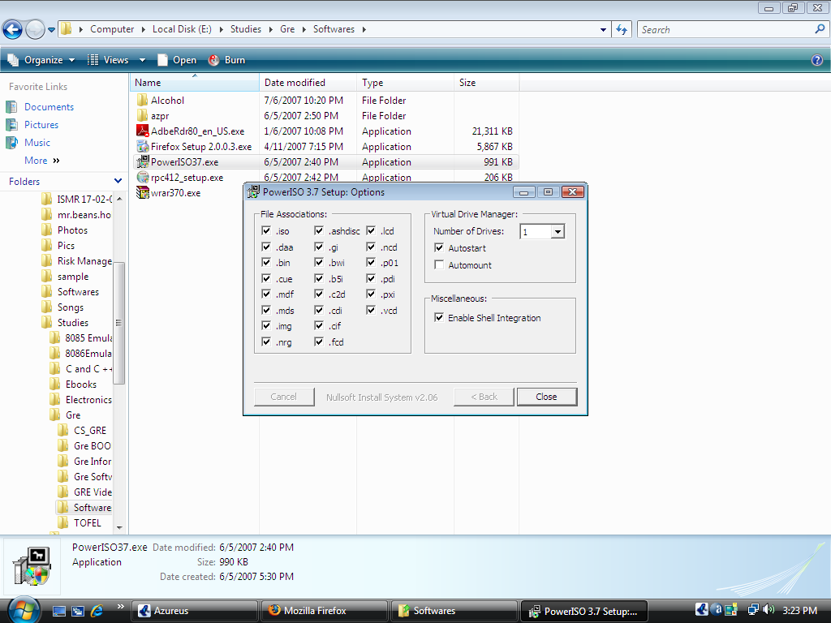

Cont’d
- After installation
Right click on the image that you want to mount as shown below.
(Image means not this image…the file types like iso is called as images)
Then Click Powersiso and go to mount E:\......... then click Drive [G} <No media>
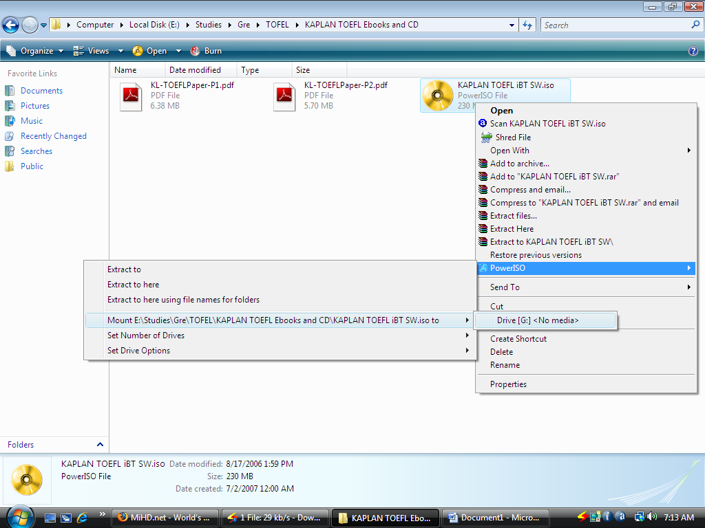

Cont’d

- After the image has been mounted
A virtual drive will appear in your My Computer. Double click on it (or) Right click on it and open it. Then complete your normal installation of that software. You have to do this same procedure for every iso files.
